Mohamed reda mohamed

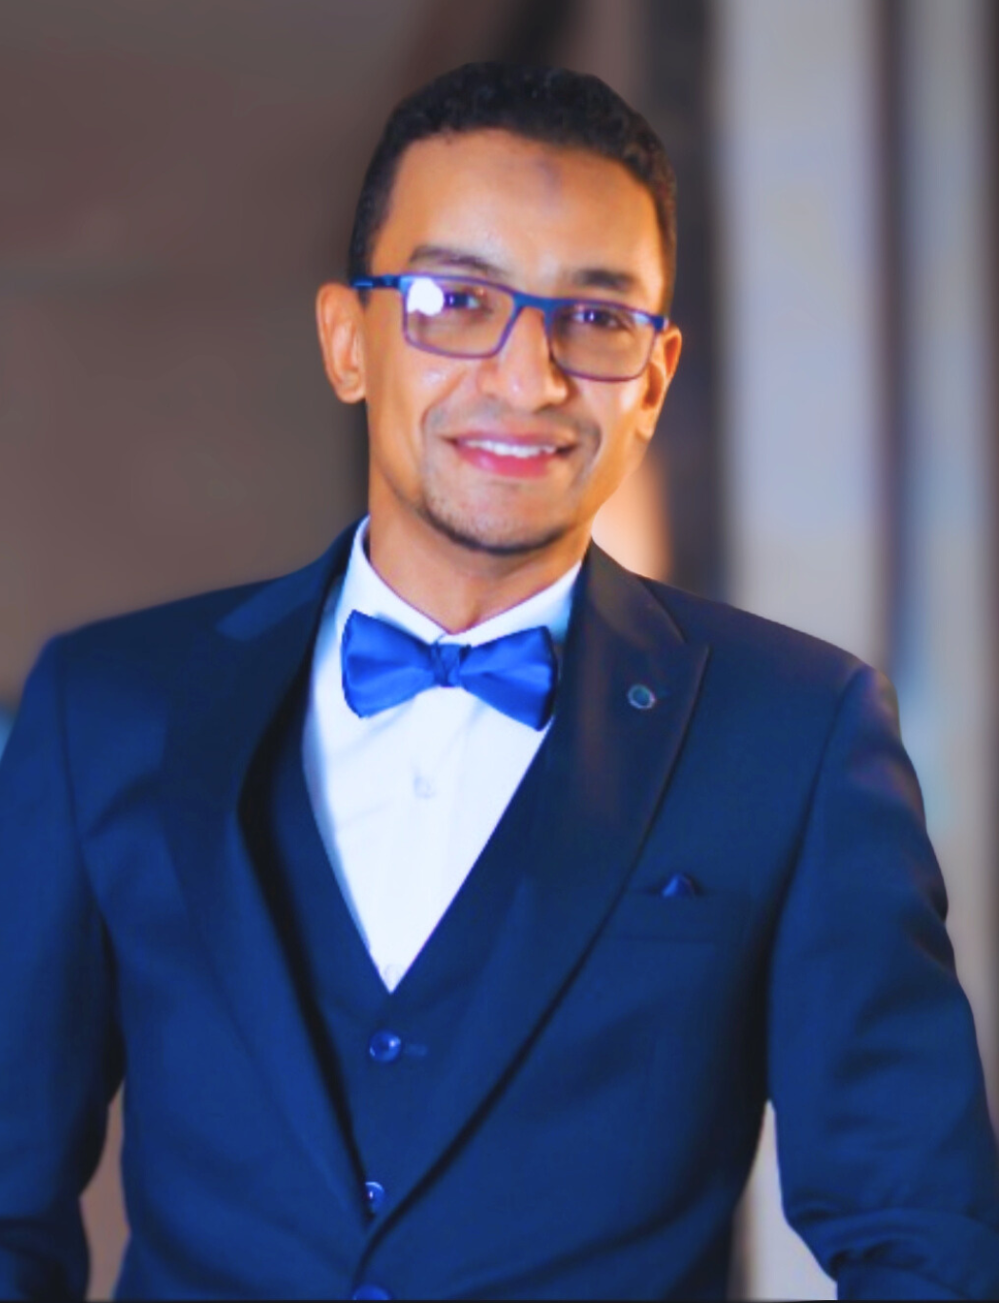

Apartment16, building107, Teba, Luxor, Egypt | 00201000317635 | [mreledresy@gmail.com](mailto:mreledresy@gmail.com)

Skilled in technical assessment of analytical laboratories based on accreditation standards (e.g., ISO/IEC 17025). Has managerial and knowledge in quality assurance and quality control issues in the field of water analysis test methods. Good command in both the English and computer knowledge. Has managerial and knowledge in quality assurance and quality control issues. Has demonstrated professional competence and mastery of subject matter.

# EXPERIENCE:

2018- present

### Lab. Manager, North Luxor Lab., Luxor Company for Water & Waste Water.

* Leading the establishment of developed chemical and microbiological laboratories from scratch in North Luxor administration for Water & Waste Water.
* Oversee the installation, calibration, operation, and maintenance of all the Equipments in the laboratory.
* Technical management of all water treatment units from raw water to the final stage of Treatment in several Water Treatment Plants.
* Supervise all quality staff, and provide guidance and training.
* Setting the requirements & Specifications of all The Lab. needs From Equipments, materials & Chemicals and Receiving them from suppliers & monitoring their compliance with the requirements of Lab.
* Lead the implementation of the quality management system and manage the Lab. team during External Auditing from ISO 17025 Inspection bodies.
* Responsible for the overall organizing and development of the laboratory and its activities.
* Making the recommendations and decisions concerning test results and sign the issued reports and certificates.
* Lead internal audits to ensure compliance with ISO 17025 Requirements.
* Oversee best control programs in the plants.
* Provide technical support to operation bodies in water treatment plant to improve operational efficiency and reduce costs.
* Keep accurate documentation and perform statistical analysis.
* Following the complaints and nonconforming works solving whether internally or externally and follow up the corrective actions.
* Provide developmental ideas and suggestions for continuous improvement.
* Obtaining ISO/IEC 17025:2017 Accreditation to the Lab in some chemical tests.

2010-2018

**Lab. Chemist, Al saida water treatment plant, Luxor Company for water & wastewater**.

* Chemical, physical, and microbiological analysis of raw water, treated water in all treatment stages and ﬁnished products according to a predetermined sampling plan and SOPs.
* Operate, calibrate, and maintain all lab equipment, including conductivity meter, PH meter, spectrophotometer, turbidity meter, manifold, autoclave, incubator, laminar flow, magnetic stirrer, water bath, and balances, in accordance with work instructions.
* Preparation of chemical reagents, standard solutions, and culture media.
* Perform all required intermediate check for all equipment & quality control programe tests .
* Prepare lab supplies stock, chemical inventory, and purchase requisitions.
* Control activities related to all water treatment units (chlorine injection, sand ﬁlter, ﬁltration, Chemicals addition unit) and guide operators.
* Perform the scheduled Maintenance processes for all the Lab. Equipments & doseing equipments in the plant.

### 2007-2008

Medical analysis specialist, in both (Alkamal Lab. For Medical analysis) & (Health insurance organization).

* Record and keep samples taken.
* Performing internal and external quality control tests.
* Separate the samples in the correct way and distribute them to the different units.
* Carrying out chemical analyzes blood tests, bacteriological cultures and clotting research, all on the apparatus to be worked on.
* Performing a system of internal and external controls, monitoring their results and recording them according to doing the work.
* Carry out regular maintenance of the devices according to the operating instructions of the device.
* Perform a microscopic examination of urine, stool and semen samples.
* drawing samples in the correct way according to the drawing instructions.
* Monitor laboratory stocks of solutions, chemicals and other supplies and ensure the optimum use of them on an ongoing basis.
* Keeping records, forms and files, participating in preparing reports.

# EDUCATION:

Bachelor of Science - special chemistry department Al-Azhar University (year 2005).

General degree: very good.

Analytical biochemistry Diploma, Science Faculty, Alexandreia University ( year 2007).

General degree: good.

# SKILLS:

|  |  |
| --- | --- |
| knowledge of Microsoft office  Labs planning & Management  Very good in English | Good in looking for information on internet  Good comunication skills  Fast learning & accomodating |